Experiment – 1

Aim:- To implement Linear Search and Binary search, compare and analyse its time complexities.

Code (Binary Search):-

using namespace std;

int binarySearch(int arr[], int low, int high, int x)
{
while (low <= high) {
int mid = low + (high - low) / 2;

if (arr[mid] == x)
return mid;

if (arr[mid] < x)
low = mid + 1;

else
high = mid - 1;
}

return -1;
}

int main(void)
{
int arr[] = { 10, 23, 25, 70, 11, 15 };
cout << "the array is10 23 45 70 11 15";
int x = 70;
cout << "the element we need to found is 70";
int n = sizeof(arr) / sizeof(arr[0]);
int result = binarySearch(arr, 0, n - 1, x);
if (result == -1) cout << "Element is not present in array";
else cout << "Element found at index " << result;
return 0;
}

Output:-

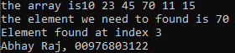

Code (Linear Search):-

#include <iostream>
using namespace std;

int linearSearch(int arr[], int n, int target) {
for (int i = 0; i < n; i++) {
if (arr[i] == target) {
return i; // Return the index if the target is found
}
}
return -1; // Return -1 if the target is not found
}

int main() {
int arr[] = { 10, 23, 45, 70, 11, 15 };
int size = sizeof(arr) / sizeof(arr[0]);
cout << "the array is";
for (int i = 0; i < size; i++) {
cout << arr[i] << " ";

}
int n = sizeof(arr) / sizeof(arr[0]);
int target = 70;
cout << endl << "the element we need to found is 70" << endl;

int result = linearSearch(arr, n, target);
if (result != -1) {
cout << "Element found at index " << result << endl;
}
else {
cout << "Element not found" << endl;
}
cout << "Abhay, 00976803122";
return 0;
}

Output:-
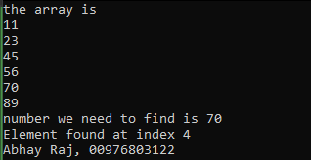

Experiment – 2

Aim:- To Implement following algorithm using array as a data structure and analyse its time complexities.

a. Insertion Sort

Code:-

#include <iostream>
#include <time.h>
#include <vector>
#include <math.h>
using namespace std;
int maxSize = 500;
enum test_c {BEST,AVERAGE,WORST};

void P_Arr(vector<int> arr) {
for (int i = 0; i < maxSize; ++i)
cout << arr[i] << " ";
cout << endl;
}
void InsSort(vector<int> &arr, int n) {
for (int i = 1; i < n; ++i) {
int key = arr[i];
int j = i - 1;
while (j >= 0 && arr[j] > key) {
arr[j + 1] = arr[j]; --j;
} arr[j + 1] = key;
}
}
vector<int> C_Arr(test_c c) {
vector<int> arr; int j = 0;
if(c == BEST)
for (int i = 0; i < maxSize; i++)
arr.push_back(i);
else if (c == WORST)
for (int i = 0; i < maxSize; ++i)
arr.push_back(maxSize - i);
else if (c == AVERAGE)
for (int i = 0; i < maxSize; ++i)
arr.push_back(rand() % maxSize);
return arr;
}
void Sort(vector<int> &arr, string arg){
clock_t start, end;
start = clock();
InsSort(arr, maxSize);
end = clock();

cout << arg << "\nTime Required: " << (end - start / CLK_TCK) << endl;
}
int main() {
vector<int> arr1 = C_Arr(BEST);
vector<int> arr2 = C_Arr(AVERAGE);
vector<int> arr3 = C_Arr(WORST);

cout << "Original array: ";
P_Arr(arr2);

Sort(arr1,"(Best Case)");
Sort(arr2, "(Average Case)");
Sort(arr3, "(Worst Case)");

cout << "Sorted array: ";
P_Arr(arr1);

cout << "Abhay Raj, 00976803122";
}

Output:-

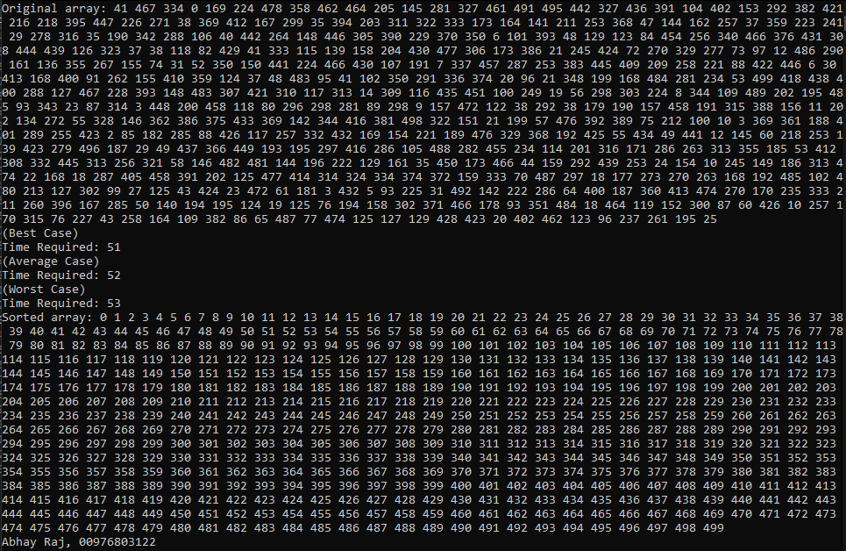

Graph:-

Best | Average | Worst | size
0 | 81 | 226 | 5000
1 | 286 | 853 | 10000
1 | 641 | 1905 | 15000
2 | 1107 | 3353 | 20000
2 | 1760 | 5285 | 25000
4 | 2577 | 7658 | 30000
4 | 3465 | 10416 | 35000

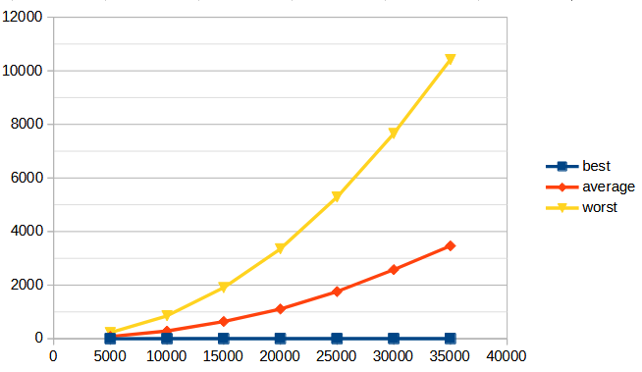

b. Bubble Sort

Code:-

#include <iostream>
#include <time.h>
#include <vector>
#include <math.h>
using namespace std;
int maxSize = 35000;
void P_Arr(vector<int> arr) {
for (int i = 0; i < maxSize; ++i)
cout << arr[i] << " ";
cout << endl;
}
void BubbleSort(vector<int>& arr) {
int n = arr.size();
for (int i = 0; i < n - 1; ++i) {
bool swapped = false;
for (int j = 0; j < n - i - 1; ++j) {
if (arr[j] > arr[j + 1]) {
swap(arr[j], arr[j + 1]);
swapped = true;
}
}if (!swapped) break;
}
}
void Sort(vector<int>& arr, string arg) {
clock_t start, end;
start = clock();
BubbleSort(arr);
end = clock();
cout << arg << "\nTime Required: " << (end - start / CLK_TCK) << endl;
}

int main() {
vector<int> arr1,arr2,arr3;
for (int i = 0; i < maxSize; i++)
arr1.push_back(i);
for (int i = 0; i < maxSize; ++i)
arr3.push_back(maxSize - i);
for (int i = 0; i < maxSize; ++i)
arr2.push_back(rand() % maxSize);

cout << "Original array: ";
P_Arr(arr2);
Sort(arr1, "(Best Case)");
Sort(arr2, "(Average Case)");
Sort(arr3, "(Worst Case)");
cout << "Sorted array: ";
P_Arr(arr1);
}

Output:-

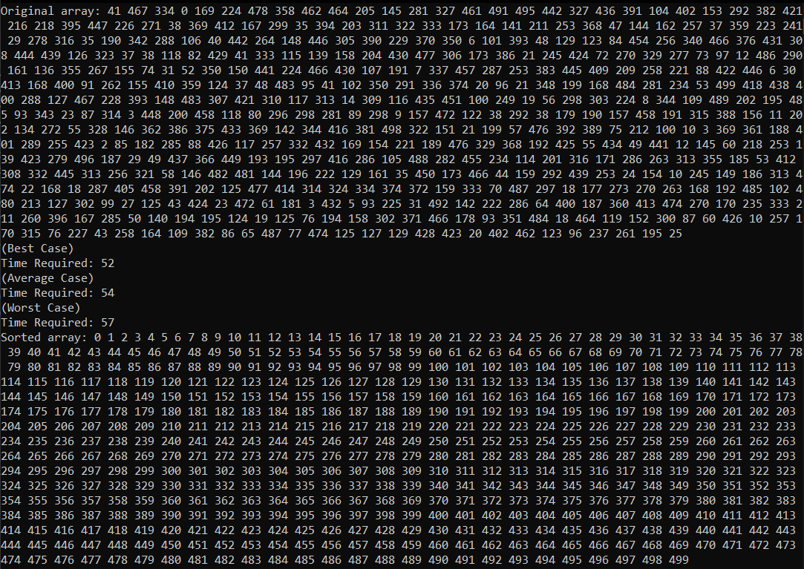

Graph:-

Best | Average | Worst | size
2 | 229 | 289 | 5000
2 | 864 | 1004 | 10000
4 | 1804 | 2294 | 15000
5 | 3144 | 3974 | 20000
5 | 4937 | 6164 | 25000
7 | 7083 | 8906 | 30000
8 | 9767 | 12232 | 35000

c. Selection Sort

Code:-

#include <iostream>
#include <vector>
#include <ctime>
using namespace std;
int maxSize = 500;
void P_Arr(const vector<int>& arr) {
for (int i = 0; i < maxSize; ++i)
cout << arr[i] << " ";
cout << endl;
}
void SelectionSort(vector<int>& arr) {
int n = arr.size();
for (int i = 0; i < n - 1; ++i) {
int minIndex = i;
for (int j = i + 1; j < n; ++j) {
if (arr[j] < arr[minIndex]) {
minIndex = j;
}
}
if (minIndex != i) {
swap(arr[i], arr[minIndex]);
}
}
}
void Sort(vector<int>& arr, const string& arg) {
clock_t start = clock();
SelectionSort(arr);
clock_t end = clock();
cout << arg << "\nTime Required: " << (end - start) / (double)CLK_TCK << " seconds" << endl;
}

int main() {
vector<int> arr1, arr2, arr3;
for (int i = 0; i < maxSize; i++)
arr1.push_back(i);
for (int i = 0; i < maxSize; ++i)
arr2.push_back(rand() % maxSize);
for (int i = 0; i < maxSize; ++i)
arr3.push_back(maxSize - i);

cout << "Original array: ";
P_Arr(arr2);
Sort(arr1, "(Best Case)");
Sort(arr2, "(Average Case)");
Sort(arr3, "(Worst Case)");
cout << "Sorted array: ";
P_Arr(arr1);

cout << "Abhay Raj, 00976803122";

return 0;
}

Output:-

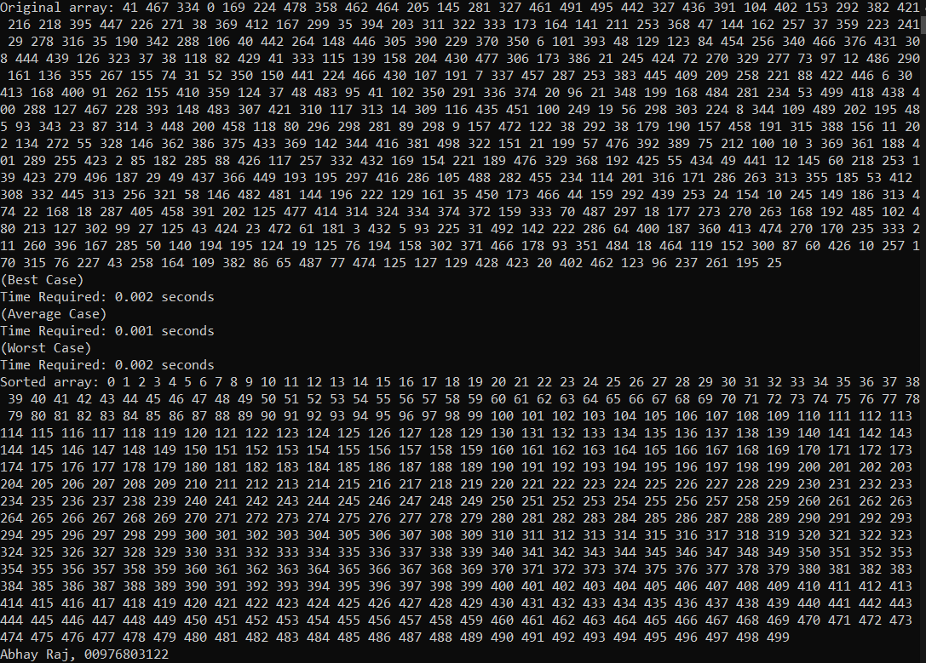

Graph:-

Best | Average | Worst | size
109 | 114 | 107 | 5000
458 | 437 | 423 | 10000
994 | 972 | 956 | 15000
1732 | 1750 | 1698 | 20000
2738 | 2710 | 2663 | 25000
3963 | 3892 | 3847 | 30000
5310 | 5365 | 5227 | 35000

d. Quick Sort

Code:-

#include <iostream>
#include <cstdlib>
#include <ctime>
#include <stack>
using namespace std;
void swap(int& a, int& b) { int temp = a; a = b; b = temp; }
int partition(int arr[], int low, int high) {
int mid = low + (high - low) / 2;
int pivot = arr[mid];
swap(arr[mid], arr[high]); int i = low - 1;
for (int j = low; j < high; j++) {
if (arr[j] < pivot) {i++;
swap(arr[i], arr[j]);
}
}swap(arr[i + 1], arr[high]);
return i + 1;
}
void qSortIter(int arr[], int l, int h) {
stack<pair<int, int>> sP;sP.push({ l, h });
while (!sP.empty()) {
pair<int, int> c = sP.top();
sP.pop();int low = c.first;
int high = c.second;
if (low < high) {
int pi = partition(arr, low, high);
if (pi - 1 - low > high - pi - 1) {
sP.push({ low, pi - 1 });
sP.push({ pi + 1, high });
}
else {
sP.push({ pi + 1, high });
sP.push({ low, pi - 1 });
}
}
}
}
void Case(int arr[], int n, const string& arg) {
clock_t start = clock();
qSortIter(arr, 0, n - 1);
clock_t end = clock();
cout << arg << "\nTime Required: " << (end - start / CLK_TCK) << endl;
}
int main() {
int n = 35000;
int* arr1 = new int[n], * arr2 = new int[n], * arr3 = new int[n];
for (int i = 0; i < n; i++) arr1[i] = i, arr2[i] = n - i, arr3[i] = rand();
Case(arr1, n, "Best");
Case(arr2, n, "Average");
Case(arr3, n, "Worst");
}
Output:-

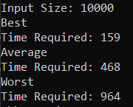

Graph:-

Best | Average | Worst | size
4 | 4 | 5 | 10000
26 | 30 | 29 | 50000
54 | 48 | 70 | 100000
229 | 217 | 384 | 500000
449 | 429 | 758 | 1000000
2314 | 2231 | 4204 | 5000000
4511 | 4491 | 9166 | 10000000

e. Merge Sort

Code:-

#include <iostream>
#include <cstdlib>
#include <ctime>
#include <stack>
using namespace std;
int n = 5000;
void merge(int arr[], int l, int m, int r) {
int n1 = m - l + 1;
int n2 = r - m;
int* L = new int[n1];
int* R = new int[n2];
for (int i = 0; i < n1; i++)
L[i] = arr[l + i];
for (int j = 0; j < n2; j++)
R[j] = arr[m + 1 + j];
int i = 0, j = 0, k = l;
while (i < n1 && j < n2) {
if (L[i] <= R[j]) {arr[k] = L[i];i++;}
else {arr[k] = R[j];j++;}k++;}
while (i < n1) {arr[k] = L[i];i++;k++;}
while (j < n2) {arr[k] = R[j];j++;k++;}
}

void mSort(int arr[], int l, int r) {
if (l < r) {
int mid = l + (r - l) / 2;
mSort(arr, l, mid);
mSort(arr, mid + 1, r);
merge(arr, l, mid, r);
}
}

void analyzeCase(int arr[], const string& arg) {
clock_t start = clock();
mSort(arr, 0, n - 1);
clock_t end = clock();
cout << arg << "\nTime Required: " << (end - start / CLK_TCK) << endl;

}
int main() {
cout << "Input Size:- " << n << endl;
int* arr1 = new int[n], * arr2 = new int[n], * arr3 = new int[n];
for (int i = 0; i < n; i++) arr1[i] = i, arr2[i] = n - i, arr3[i] = rand();
analyzeCase(arr1, "Best Case");
analyzeCase(arr2, "Average Case");
analyzeCase(arr3, "Worst Case");
cout << "Abhay Raj, 00976803122";
}

Output:-

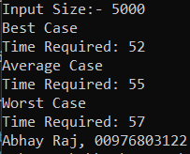

Graph:-

Best | Average | Worst | size
4 | 4 | 5 | 10000
19 | 20 | 22 | 50000
38 | 47 | 44 | 100000
241 | 237 | 188 | 500000
445 | 463 | 378 | 1000000
1973 | 2110 | 1908 | 5000000
3996 | 4012 | 3853 | 10000000

e. Heap Sort

Code:-

#include <iostream>
#include <cstdlib>
#include <ctime>
int n = 5000;
using namespace std;

void hpy(int arr[], int n, int i) {
int lg = i;
int l = 2 * i + 1;
int r = 2 * i + 2;

if (l < n && arr[l] > arr[lg])lg = l;
if (r < n && arr[r] > arr[lg])lg = r;
if (lg != i) { swap(arr[i], arr[lg]); hpy(arr, n, lg); }
}

void heapSort(int arr[], int n) {
for (int i = n / 2 - 1; i >= 0; i--)hpy(arr, n, i);
for (int i = n - 1; i > 0; i--) {swap(arr[0], arr[i]);
hpy(arr, i, 0);}
}

void analyzeCase(int arr[], const string& arg) {
clock_t start = clock();
heapSort(arr, n);
clock_t end = clock();
cout << arg << "\nTime Required: " << (end - start / CLK_TCK) << endl;
}

int main() {
cout << "Input Size: " << n << endl;
int* arr1 = new int[n], * arr2 = new int[n], * arr3 = new int[n];
for (int i = 0; i < n; i++) arr1[i] = i, arr2[i] = n - i, arr3[i] = rand();
analyzeCase(arr1, "Best");
analyzeCase(arr2, "Average");
analyzeCase(arr3, "Worst");
}

Output:-

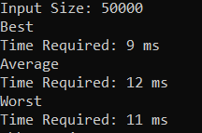

Graph:-

Best | Average | Worst | size
1 | 2 | 1 | 10000
9 | 12 | 11 | 50000
20 | 22 | 20 | 100000
122 | 152 | 133 | 500000
261 | 301 | 230 | 1000000
1332 | 1385 | 1267 | 5000000
2768 | 2988 | 2636 | 10000000

Experiment – 3

Aim:- To implement Strassen’s algorithm for Matrix Multiplication and analyse its time
complexity.

Code:-

#include <iostream>
#include <vector>
#include <chrono>
using namespace std;
using V = vector<int>;
using VV = vector<V>;

VV add(const VV& A, const VV& B) {
int n = A.size();
VV R(n, V(n));
for (int i = 0; i < n; ++i)
for (int j = 0; j < n; ++j)
R[i][j] = A[i][j] + B[i][j];
return R;
}

VV sub(const VV& A, const VV& B) {
int n = A.size();
VV R(n, V(n));
for (int i = 0; i < n; ++i)
for (int j = 0; j < n; ++j)
R[i][j] = A[i][j] - B[i][j];
return R;
}

VV strassen(const VV& A, const VV& B) {
int n = A.size();
if (n == 1) return { {A[0][0] * B[0][0]} };

int sz = n / 2;
VV A11(sz, V(sz)), A12(sz, V(sz)), A21(sz, V(sz)), A22(sz, V(sz));
VV B11(sz, V(sz)), B12(sz, V(sz)), B21(sz, V(sz)), B22(sz, V(sz));

for (int i = 0; i < sz; i++)
for (int j = 0; j < sz; j++) {
A11[i][j] = A[i][j]; A12[i][j] = A[i][j + sz];
A21[i][j] = A[i + sz][j]; A22[i][j] = A[i + sz][j + sz];
B11[i][j] = B[i][j]; B12[i][j] = B[i][j + sz];
B21[i][j] = B[i + sz][j]; B22[i][j] = B[i + sz][j + sz];
}

auto M1 = strassen(add(A11, A22), add(B11, B22));
auto M2 = strassen(add(A21, A22), B11);
auto M3 = strassen(A11, sub(B12, B22));
auto M4 = strassen(A22, sub(B21, B11));
auto M5 = strassen(add(A11, A12), B22);
auto M6 = strassen(sub(A21, A11), add(B11, B12));
auto M7 = strassen(sub(A12, A22), add(B21, B22));

VV C(n, V(n));
for (int i = 0; i < sz; i++) {
for (int j = 0; j < sz; j++) {
C[i][j] = M1[i][j] + M4[i][j] - M5[i][j] + M7[i][j];
C[i][j + sz] = M3[i][j] + M5[i][j];
C[i + sz][j] = M2[i][j] + M4[i][j];
C[i + sz][j + sz] = M1[i][j] - M2[i][j] + M3[i][j] + M6[i][j];
}
}

return C;
}
VV generateMatrix(int n) {
VV matrix(n, V(n));
int value = 1;
for (int i = 0; i < n; ++i)
for (int j = 0; j < n; ++j)
matrix[i][j] = value++;
return matrix;
}
int main() {
VV A = generateMatrix(32);
VV B = generateMatrix(32);

int numTrials = 10;
int duration = 0;

for (int trial = 0; trial < numTrials; ++trial) {
clock_t start = clock();
VV C = strassen(A, B);
clock_t end = clock();
duration += (end - start);
}
cout << "Average time over " << numTrials << " trials: "
<< duration << " milliseconds." << endl;
}

Output:-

Average time over 10 trials: 1566 milliseconds.

Abhay Raj, 00976803122

Graph:-

Not Applicable.
Experiment – 4

Aim:- To implement Activity Selection problem and analyse its time complexity.

Code:-

#include <iostream>
#include <vector>
#include <algorithm>
#include <ctime>
using namespace std;
struct A { int s, e; };
bool cmp(A a, A b) { return a.e < b.e; }
int maxAct(vector<A>& a) {
sort(a.begin(), a.end(), cmp);
int cnt = 1, end = a[0].e;
for (int i = 1; i < a.size(); i++) {
if (a[i].s >= end) {
cnt++;
end = a[i].e;
}
}
return cnt;
}
int main() {
const int n = 1000000;
vector<A> a(n);
for (int i = 0; i < n; ++i) {
a[i].s = i;
a[i].e = n - i;
}
clock_t start = clock();
cout << "Max activities: " << maxAct(a) << endl;
cout << "Time taken: " << double(clock() - s) / CLK_TCK << "sec" << endl;
}

Output:-

Max activities: 500000
Time taken: 0.245sec
Abhay Raj, 00976803122

Graph:-

Not Applicable.
Experiment – 5

Aim:- To implement Task Scheduling problem and analyse its time complexity.

Code:-

#include <iostream>
#include <vector>
#include <algorithm>
using namespace std;

struct Task { int id, d, p; };
bool cmp(Task a, Task b) { return a.p > b.p; }

int maxProfit(vector<Task>& tasks, int maxD) {
sort(tasks.begin(), tasks.end(), cmp);
vector<int> slot(maxD + 1, -1); int profit = 0;
for (auto& t : tasks) {
for (int j = min(maxD, t.d); j > 0; j--) {
if (slot[j] == -1) { slot[j] = t.id; profit += t.p; break; }
}
}
return profit;
}

int main() {
const int n = 1000000;
vector<Task> tasks(n);
for (int i = 0; i < n; ++i) {
tasks[i].id = i + 1;
tasks[i].d = rand() % 100 + 1;
tasks[i].p = rand() % 10 + 1;
}
clock_t start = clock();
cout << "Max Profit: " << maxProfit(tasks, 1000) << endl;
cout << "Time taken: " << double(clock() - s) / CLK_TCK << "sec" << endl;

}

Output:-

Max Profit: 1000
Time taken: 0.404sec
Abhay Raj, 00976803122

Graph:-

Not Applicable.
Experiment – 6

Aim:- To implement Huffman Coding and analyse its time complexity.

Code:-

#include <iostream>
#include <queue>
#include <unordered_map>
#include <vector>
using namespace std;

struct N {
char c; int f; N* l, * r;
N(char x, int y) : c(x), f(y), l(nullptr), r(nullptr) {}
};
struct C {
bool operator()(N* a, N* b)
{
return a->f > b->f;
}
};

void gen(N* n, string s, unordered_map<char, string>& h) {
if (!n) return;
if (!n->l && !n->r) h[n->c] = s;
gen(n->l, s + "0", h);
gen(n->r, s + "1", h);
}

void huff(string t) {
unordered_map<char, int> f;
for (char c : t) f[c]++;

priority_queue<N*, vector<N*>, C> q;
for (auto& p : f) q.push(new N(p.first, p.second));

while (q.size() > 1) {
N* l = q.top(); q.pop();
N* r = q.top(); q.pop();
N* m = new N('$', l->f + r->f);
m->l = l; m->r = r;
q.push(m);
}

unordered_map<char, string> h;
gen(q.top(), "", h);

for (auto& p : h) cout << p.first << ": " << p.second << endl;
}
int main() {
string t = "";
int n = 100000;

for (int i = 0; i < n; ++i) {
char random_char = 'a' + rand() % 26; // Generate a random lowercase letter
t.push_back(random_char);
}
clock_t start = clock();
huff(t);
cout << "Time taken: " << double(clock() - s) / CLK_TCK << "sec" << endl;
}

Output:-

f: 0001
v: 0000
p: 0010
z: 0100
j: 0011
y: 01101
q: 0101
e: 01100
u: 01110
d: 01111
g: 10000
h: 10001
x: 10010
n: 10011
l: 10100
b: 10101
c: 10110
i: 10111
k: 11000
o: 11001
t: 11010
s: 11011
w: 11100
m: 11101
a: 11110
r: 11111
Time taken: 0.011sec
Abhay Raj, 00976803122

Graph:-

Not Applicable.
Experiment – 7

Aim:- To implement Fractional Knapsack problem and analyse its time complexity

Code:-

#include <iostream>
#include <vector>
#include <algorithm>
using namespace std;

struct I {
int v, w;
double r;
I(int x, int y) : v(x), w(y), r(static_cast<double>(x) / y) {}
I() : v(0), w(1), r(0.0) {}
};
bool cmp(I a, I b) { return a.r > b.r; }

double ks(vector<I>& itms, int W) {
sort(itms.begin(), itms.end(), cmp);
double t = 0;
for (auto& i : itms) {
if (W == 0) break;
if (i.w <= W) { t += i.v; W -= i.w; }
else { t += i.v * ((double)W / i.w); break; }
}
return t;
}

int main() {
const int n = 10000;
vector<I> itms(n);
for (int i = 0; i < n; ++i) {
int v = rand() % 100 + 1;
int w = rand() % 100 + 1;
itms.emplace_back(v, w);
}
clock_t s = clock();
int W = 50;
cout << "Maximum value in Knapsack: " << ks(itms, W) << endl;
cout << "Time taken: " << double(clock() - s) / CLK_TCK << "sec" << endl;
}

Output:-

Maximum value in Knapsack: 3524
Time taken: 0.011sec
Abhay Raj, 00976803122

Graph:-

Not Applicable.
Experiment – 8

Aim:- To implement Matrix Chain Multiplication problem using iteration and analyse its
time complexity.

Code:-

#include <iostream>
#include <vector>
#include <climits>
using namespace std;

int matrixChainOrder(vector<int>& p) {
int n = p.size() - 1;
vector<vector<int>> m(n, vector<int>(n, 0));

for (int l = 2; l <= n; ++l) {
for (int i = 0; i < n - l + 1; ++i) {
int j = i + l - 1;
m[i][j] = INT_MAX;
for (int k = i; k < j; ++k) {
int q = m[i][k] + m[k + 1][j] + p[i] * p[k + 1] * p[j + 1];
if (q < m[i][j]) m[i][j] = q;
}
}
}

return m[0][n - 1];
}

int main() {
const int n = 500;
vector<int> p(n);
for (int i = 0; i < n; ++i) {
int r = rand() % 100 + 1;
p[i] = r;
}
clock_t s = clock();
cout << "Minimum multiplications: " << matrixChainOrder(p) << endl;
cout << "Time taken: " << double(clock() - s) / CLK_TCK << "sec" << endl;
}

Output:-

Minimum number of multiplications is 1249064
Time taken: 0.762sec
Abhay Raj, 00976803122

Graph:-

Not Applicable.
Experiment – 9

Aim:- To implement Matrix Chain Multiplication problem using recursion and analyse
its time complexity.

Code:-

#include <iostream>
#include <vector>
#include <climits>
using namespace std;
int mcm(const vector<int>& d, int i, int j) {
if (i == j) return 0;
int mn = INT_MAX;
for (int k = i; k < j; ++k)
mn = min(mn, mcm(d, i, k) + mcm(d, k + 1, j) + d[i - 1] * d[k] * d[j]);
return mn;
}
int minMult(const vector<int>& d) {
return mcm(d, 1, d.size() - 1);
}
int main() {
const int n = 15;
vector<int> p(n);
for (int i = 0; i < n; ++i) {
int r = rand() % 100 + 1;
p[i] = r;
}
clock_t s = clock();
cout << "Minimum multiplications: " << minMult(p) << endl;
cout << "Time taken: " << double(clock() - s) / CLK_TCK << "sec" << endl;
}

Output:-

Minimum multiplications: 32508
Time taken: 0.045sec
Abhay Raj, 00976803122

Graph:-
Experiment – 10

Aim:- To implement Memorized Matrix Chain Multiplication problem and analyse its
time complexity and compare with the iterative and recursive methods.

Code:-

#include <iostream>
#include <vector>
#include <climits>
using namespace std;

int mcm(const vector<int>& d, int i, int j, vector<vector<int>>& m) {
if (i == j) return 0;
if (m[i][j] != -1) return m[i][j];
int mn = INT_MAX;
for (int k = i; k < j; ++k)
mn = min(mn, mcm(d, i, k, m) + mcm(d, k + 1, j, m) + d[i - 1] * d[k] * d[j]);
return m[i][j] = mn;
}

int minMult(const vector<int>& d) {
int n = d.size();
vector<vector<int>> m(n, vector<int>(n, -1));
return mcm(d, 1, n - 1, m);
}

int main() {
const int n = 50;
vector<int> p(n);
for (int i = 0; i < n; ++i) {
int r = rand() % 100 + 1;
p[i] = r;
}
clock_t s = clock();
cout << "Minimum multiplications: " << minMult(p) << endl;
cout << "Time taken: " << double(clock() - s) / CLK_TCK << "sec" << endl;
}

Output:-

Minimum multiplications: 120255
Time taken: 0.002sec
Abhay Raj, 00976803122

Graph:-
Experiment – 11

Aim:- To implement Longest Common Subsequence problem and analyse its time
complexity.

Code:-

#include <iostream>
#include <vector>
#include <ctime>
using namespace std;

int lcs(const string& x, const string& y) {
int m = x.size(), n = y.size();
vector<vector<int>> dp(m + 1, vector<int>(n + 1, 0));
for (int i = 1; i <= m; ++i)
for (int j = 1; j <= n; ++j)
dp[i][j] = (x[i - 1] == y[j - 1]) ? dp[i - 1][j - 1] + 1 :
max(dp[i - 1][j], dp[i][j - 1]);
return dp[m][n];
}

string genStr(int l) {
string s(l, ' ');
for (int i = 0; i < l; ++i) s[i] = 'a' + rand() % 26;
return s;
}

string genY(const string& x, int l) {
string y = x.substr(rand() % (x.size() - l / 2 + 1), l / 2);
while (y.size() < l) y += 'a' + rand() % 26;
return y;
}

int main() {
int n = 5000;
string x = genStr(n), y = genY(x, n);
clock_t s = clock();
cout << "LCS Len: " << lcs(x, y) << endl;
cout << "Time: " << double(clock() - s) / CLOCKS_PER_SEC << " sec" << endl;
}

Output:-

LCS Len: 2886
Time: 1.417 sec
Abhay Raj, 00976803122

Graph:-
Experiment – 12

Aim:- To implement Optimal Binary Search Tree problem and analyse its time
complexity.

Code:-

#include <iostream>
#include <vector>
#include <climits>
#include <vector>
using namespace std;
using V = vector<int>;
using VV = vector<V>;

int optimalBST(const vector<int>& freq) {
int n = freq.size();
VV dp(n, V(n, 0));
VV sum(n, V(n, 0));

for (int i = 0; i < n; ++i) sum[i][i] = freq[i];
for (int len = 2; len <= n; ++len) {
for (int i = 0; i <= n - len; ++i) {
int j = i + len - 1;
sum[i][j] = sum[i][j - 1] + freq[j];
dp[i][j] = INT_MAX;
for (int r = i; r <= j; ++r) {
int cost = (r > i ? dp[i][r - 1] : 0) + (r < j ? dp[r + 1][j] : 0) + sum[i][j];
dp[i][j] = min(dp[i][j], cost);
}
}
}
return dp[0][n - 1];
}

int main() {
const int n = 200;
V p(n);
for (int i = 0; i < n; ++i) {
int r = rand() % 100 + 1;
p[i] = r;
}
clock_t s = clock();
cout << "Optimal BST cost: " << optimalBST(p) << endl;
cout << "Time taken: " << double(clock() - s) / CLK_TCK << "sec" << endl;
}

Output:-

Optimal BST cost: 56698
Time taken: 0.061sec
Abhay Raj, 00976803122

Graph:-
Experiment – 13

Aim:- To implement 0-1 Knapsack problem and analyse its time complexity.

Code:-

#include <iostream>
#include <vector>
#include <algorithm>
using namespace std;
using V = vector<int>;

int knapsack(int W, const V& wt, const V& val, int n) {
V dp(W + 1, 0);
for (int i = 1; i <= n; ++i) {
for (int w = W; w >= wt[i - 1]; --w) {
dp[w] = max(dp[w], dp[w - wt[i - 1]] + val[i - 1]);
}
}
return dp[W];
}

int main() {
int n = 100000;
int W = 50;
V wt(n);
V val(n);
for (int i = 0; i < n; ++i) {
int r1 = rand() % 100 + 1;
int r2 = rand() % 100 + 1;
wt[i] = r1;
val[i] = r2;
}
clock_t s = clock();
cout << "Max value in Knapsack: " << knapsack(W, wt, val, n) << endl;
cout << "Time taken: " << double(clock() - s) / CLK_TCK << "sec" << endl;
}

Output:-

Max value in Knapsack: 4911
Time taken: 0.036sec
Abhay Raj, 00976803122

Graph:-
Experiment – 14

Aim:- To implement Binomial coefficient problem and analyse its time complexity.

Code:-
#include <iostream>
#include <vector>
using namespace std;
using V = vector<long>;

int binomial(int n, int k) {
V dp(k + 1, 0);
dp[0] = 1;
for (int i = 1; i <= n; ++i) {
for (int j = min(i, k); j > 0; --j) {
dp[j] += dp[j - 1];
}
}
return dp[k];
}

int main() {
int n = 5000000, k = 3;
clock_t s = clock();
cout << "Binomial Coefficient C(" <<
n << ", " << k << ") = " << binomial(n, k) << endl;
cout << "Time taken: " << double(clock() - s) / CLK_TCK << "sec" << endl;
}

Output:-

Binomial Coefficient C(5000000, 3) = 313359296
Time taken: 0.138sec
Abhay Raj, 00976803122

Graph:-
Experiment – 15

Aim:- To implement Breadth First Search and analyse its time complexity.

Code:-

#include <iostream>
#include <vector>
#include <queue>
#include <ctime>
#include <cstdlib>
using namespace std;
using V = vector<int>;
using VV = vector<V>;

VV genGraph(int n, double p = 0.3) {
VV adj(n);
srand(time(0));
for (int i = 0; i < n; ++i)
for (int j = i + 1; j < n; ++j)
if ((rand() / (double)RAND_MAX) < p)
adj[i].push_back(j), adj[j].push_back(i);
return adj;
}

void bfs(int s, const VV& adj) {
vector<bool> vis(adj.size(), false);
queue<int> q;
vis[s] = true;
q.push(s);
while (!q.empty()) {
int n = q.front();
q.pop();
cout << n << " ";
for (int nb : adj[n])
if (!vis[nb])
vis[nb] = true, q.push(nb);
}
}

int main() {
int n = 10;
VV adj = genGraph(n, 0.3);
cout << "\nBFS from 0: ";
clock_t s = clock();
bfs(0, adj);
cout << endl;
cout << "Time taken: " << double(clock() - s) / CLK_TCK << "sec" << endl;
}

Output:-

BFS from 0: 0 1 4 5 7 9 2 3 8 6
Time taken: 0.001sec
Abhay Raj, 00976803122

Graph:-
Experiment – 16

Aim:- To implement Depth First Search and analyse its time complexity.

Code:-

#include <iostream>
#include <vector>
#include <stack>
#include <ctime>
using namespace std;

class G {
int n; vector<vector<int>> adj;
public:
G(int sz) : n(sz), adj(sz) {}
void add(int u, int v) { adj[u].push_back(v); adj[v].push_back(u); }
void dfs(int st) {
vector<bool> vis(n, 0); stack<int> s; s.push(st);
while (!s.empty()) {
int v = s.top(); s.pop();
if (!vis[v]) {
vis[v] = 1; cout << v << " ";
for (int nb : adj[v]) if (!vis[nb]) s.push(nb);
}
}
}
};

void gen(int n) {
G g(n); srand(time(0));
for (int i = 0; i < n; ++i) {
int u = rand() % n, v = rand() % n;
if (u != v) g.add(u, v);
}
g.dfs(0);
}
int main() {
int n = 10;
clock_t s = clock();
gen(n);
cout << "\nTime taken: " << double(clock() - s) / CLK_TCK << "sec" << endl;
}

Output:-

0 4 8 5 2 6 9 3
Time taken: 0sec
Abhay Raj, 00976803122

Graph:-
Experiment – 17

Aim:- To implement Kruskal’s algorithm for minimum cost spanning tree and analyse
its time complexity.

Code:-
#include <iostream>
#include <vector>
#include <cstdlib>
#include <ctime>
#include <algorithm>
using namespace std;

struct E { int u, v, w; bool operator<(const E& e) const { return w < e.w; } };
class G {
int v;
vector<E> e;
public:
G(int n) : v(n) {}
void add(int u, int v, int w) { e.push_back({ u, v, w }); }
int find(int v, vector<int>& p) { return v == p[v] ? v : p[v] = find(p[v], p); }
void unite(int u, int v, vector<int>& p, vector<int>& r) {
u = find(u, p); v = find(v, p);
if (u != v) { r[u] < r[v] ? p[u] = v : p[v] = u; r[u] == r[v] ? r[u]++ : 0; }
}
int kruskal() {
sort(e.begin(), e.end());
vector<int> p(v), r(v, 0);
for (int i = 0; i < v; i++) p[i] = i;
int w = 0;
for (auto& ed : e) {
int u = find(ed.u, p), v = find(ed.v, p);
if (u != v) { w += ed.w; unite(u, v, p, r); }
}
return w;
}
void genRand(int m) {
srand(time(0));
for (int i = 0; i < m; i++) add(rand() % v, rand() % v, rand() % 100 + 1);
}
};

int main() {
G g(5); g.genRand(10);
clock_t s = clock();
cout << "MST Cost: " << g.kruskal() << endl;
cout << "MST Edges: " << endl;
cout << "Time taken: " << double(clock() - s) / CLK_TCK << "sec" << endl;
}

Output:-

MST Cost: 61
Time taken: 0.001sec
Abhay Raj, 00976803122

Graph:-
Experiment – 18

Aim:- To implement Prim’s algorithm for minimum cost spanning tree and analyse its
time complexity.

Code:-
#include <iostream>
#include <vector>
#include <queue>
#include <cstdlib>
#include <ctime>
using namespace std;

struct E {
int u, v, w;
bool operator>(const E& e) const { return w > e.w; }
};

class G {
int V;
vector<vector<pair<int, int>>> adj;
public:
G(int n) : V(n), adj(n) {}
void addE(int u, int v, int w) {
adj[u].push_back({ v, w });
adj[v].push_back({ u, w });
}
int prim() {
priority_queue<E, vector<E>, greater<E>> pq;
vector<bool> inMST(V, false);
int mstW = 0;
pq.push({ -1, 0, 0 });
while (!pq.empty()) {
int u = pq.top().v, w = pq.top().w;
pq.pop();
if (inMST[u]) continue;
inMST[u] = true;
mstW += w;
for (auto& e : adj[u]) {
if (!inMST[e.first]) pq.push({ u, e.first, e.second });
}
}
return mstW;
}
};
void createG(G& g, int n, int m) {
srand(time(0));
for (int i = 0; i < m; ++i) {
int u = rand() % n, v = rand() % n;
if (u != v) g.addE(u, v, rand() % 100 + 1);
}
}
int main() {
int n = 1000;
G g(n);
createG(g, n, n*2);
clock_t s = clock();
cout << "MST Cost: " << g.prim() << endl;
cout << "Time taken: " << double(clock() - s) / CLK_TCK << "sec" << endl;
}

Output:-

MST Cost: 27567
Time taken: 0.004sec
Abhay Raj, 00976803122

Graph:-
Experiment – 19

Aim:- To implement Dijkstra’s single source shortest path algorithm and analyse its time
complexity in different cases.

Code:-

#include <iostream>
#include <vector>
#include <queue>
#include <climits>
using namespace std;

class G {
int V;
vector<vector<pair<int, int>>> adj;
public:
G(int n) : V(n), adj(n) {}
void addE(int u, int v, int w) {
adj[u].push_back({ v, w });
adj[v].push_back({ u, w });
}
vector<int> dijkstra(int src) {
vector<int> dist(V, INT_MAX);
priority_queue<pair<int, int>, vector<pair<int, int>>, greater<pair<int, int>>> pq;
dist[src] = 0;
pq.push({ 0, src });
while (!pq.empty()) {
int u = pq.top().second, d = pq.top().first;
pq.pop();
if (d > dist[u]) continue;
for (auto& e : adj[u]) {
int v = e.first, w = e.second;
if (dist[u] + w < dist[v]) {
dist[v] = dist[u] + w;
pq.push({ dist[v], v });
}
}
}
return dist;
}
};
void createG(G& g, int n, int m) {
srand(time(0));
for (int i = 0; i < m; ++i) {
int u = rand() % n, v = rand() % n;
if (u != v) g.addE(u, v, rand() % 100 + 1);
}
}
int main() {
int n = 10;
G g(n);
createG(g, n, n*2);
clock_t s = clock();
vector<int> dist = g.dijkstra(0);
cout << "Time taken: " << double(clock() - s) / CLK_TCK << "sec" << endl;
cout << "Distances from source: ";
for (int i : dist) cout << i << " ";
cout << endl;
}

Output:-

Time taken: 0sec
Distances from source: 0 50 66 47 108 105 180 106 178 40
Abhay Raj, 00976803122

Graph:-
Experiment – 20

Aim:- To implement single source shortest path Bellman Ford algorithm and analyse its
time complexity.

Code:-

#include <iostream>
#include <vector>
#include <tuple>
#include <climits>
using namespace std;
class G {
int v;
vector<tuple<int, int, int>> e;
public:
G(int n) : v(n) {}
void add(int u, int w, int wt) { e.emplace_back(u, w, wt); }
vector<int> bF(int s) {
vector<int> d(v, INT_MAX); d[s] = 0;
for (int i = 0; i < v - 1; ++i)
for (auto& edge : e) {
int u = get<0>(edge), w = get<1>(edge), wt = get<2>(edge);
if (d[u] != INT_MAX && d[u] + wt < d[w])
d[w] = d[u] + wt;
}
for (auto& edge : e) {
int u = get<0>(edge), w = get<1>(edge), wt = get<2>(edge);
if (d[u] != INT_MAX && d[u] + wt < d[w])
cout << "Negative Cycle Detected\n";
}
return d;
}
};
void gen(G& g, int n, int m) {
for (int i = 0; i < m; ++i) {
int u = rand() % n, v = rand() % n;
if (u != v) g.add(u, v, rand() % 50 - 25);
}
}
int main() {
int n = 5;
G g(n); gen(g, n, n+2);
clock_t s = clock();
for (int x : g.bF(0)) cout << x << " ";
cout << "\nTime taken: " << double(clock() - s) / CLK_TCK << "sec" << endl;
}

Output:-

0 2 2 2147483647 -18
Time taken: 0sec
Abhay Raj, 00976803122

Graph:-
Experiment – 21

Aim:- To implement all pair shortest path algorithm and analyse its time complexity.

Code:-

#include <iostream>
#include <vector>
#include <climits>
#include <cstdlib>
#include <ctime>
using namespace std;
#define INF INT_MAX
void matrixMultiplication(vector<vector<int>>& dist, int V) {
for (int k = 0; k < V; ++k) {
for (int i = 0; i < V; ++i) {
for (int j = 0; j < V; ++j) {
if (dist[i][k] != INF && dist[k][j] != INF) {
dist[i][j] = min(dist[i][j], dist[i][k] + dist[k][j]);
}
}
}
}
}

int main() {
int n = 5;
int V = n;
int E = n+5;

vector<vector<int>> dist(V, vector<int>(V, INF));
for (int i = 0; i < V; ++i) {
dist[i][i] = 0;
}
cout << "Generated Edges:\n";
for (int i = 0; i < E; ++i) {
int u = rand() % V;
int v = rand() % V;
int weight = rand() % 10 + 1;
while (u == v) {
v = rand() % V;
}

dist[u][v] = weight;
cout << u << " " << v << " " << weight << endl;
}
matrixMultiplication(dist, V);
cout << "Shortest Path Matrix:\n";
for (int i = 0; i < V; ++i) {
for (int j = 0; j < V; ++j) {
if (dist[i][j] == INF) cout << "INF ";
else cout << dist[i][j] << " ";
}
cout << endl;
}
}

Output:-

Generated Edges:
1 2 5
0 4 5
3 4 3
0 2 2
1 2 6
2 1 2
4 2 4
2 1 2
3 0 8
1 4 9
Shortest Path Matrix:
0 4 2 INF 5
INF 0 6 INF 9
INF 2 0 INF 11
8 9 7 0 3
INF 6 4 INF 0
Abhay Raj, 00976803122

Graph:-
Experiment – 22

Aim:- To implement all pair shortest path Floyd Warshall algorithm and analyse its time
complexity.

Code:-

#include <iostream>
#include <vector>
#include <climits>
#include <ctime>
#include <cstdlib>
using namespace std;

class G {
public:
int V;
vector<vector<int>> d;
G(int v) : V(v) {
d.resize(V, vector<int>(V, INT_MAX));
for (int i = 0; i < V; ++i) d[i][i] = 0;
}
void aE(int u, int v, int w) {
if (u >= 0 && u < V && v >= 0 && v < V) {
d[u][v] = w;
d[v][u] = w;
}
}
void fW() {
for (int k = 0; k < V; ++k)
for (int i = 0; i < V; ++i)
for (int j = 0; j < V; ++j)
if (d[i][k] != INT_MAX && d[k][j] != INT_MAX)
d[i][j] = min(d[i][j], d[i][k] + d[k][j]);
}
void print() {
for (int i = 0; i < V; ++i) {
for (int j = 0; j < V; ++j) {
if (d[i][j] == INT_MAX) cout << "INF ";
else cout << d[i][j] << " ";
}
cout << endl;
}
}
};
void cG(G& g, int n) {
srand(time(0));
for (int i = 0; i < n; ++i) {
for (int j = i + 1; j < n; ++j) {
int weight = rand() % 20 + 1;
g.aE(i, j, weight);
}
}
}
int main() {
int n = 5; G g(n);
cG(g, n);clock_t s = clock();
g.fW();
cout << "Time taken: " << double(clock() - s) / CLK_TCK << "sec" << endl;
g.print();
}

Output:-

Time taken: 0sec
0 11 2 4 12
11 0 9 7 17
2 9 0 6 12
4 7 6 0 10
12 17 12 10 0
Abhay Raj, 00976803122

Graph:-
Experiment – 23

Aim:- To implement naive string matching algorithm and analyse its time complexity.

Code:-

#include <iostream>
#include <string>
using namespace std;

int nm(string t, string p) {
int n = t.size(), m = p.size();
for (int i = 0; i <= n - m; ++i) {
int j = 0;
while (j < m && t[i + j] == p[j]) j++;
if (j == m) return i;
}
return -1;
}

int main() {
string t = "ABABDABACDABABCABAB", p = "ABABCABAB";
int idx = nm(t, p);
cout << (idx == -1 ? "Not Found" : "Found at " + to_string(idx)) << endl;
return 0;
}

Output:-

Found at 10
Abhay Raj, 00976803122

Graph:-
Experiment – 24

Aim:- To implement Rabin Karp algorithm and analyse its time complexity.

Code:-

#include <iostream>
#include <string>
#include <cstdlib>
#include <ctime>
using namespace std;

string genStr(int n) {
string s = "";
char c[] = "ABCDEFGHIJKLMNOPQRSTUVWXYZabcdefghijklmnopqrstuvwxyz0123456789";
for (int i = 0; i < n; i++) s += c[rand() % 62];
return s;
}

int rk(string t, string p) {
int n = t.size(), m = p.size(), d = 256, q = 101, h = 1;
int ph = 0, th = 0;
for (int i = 0; i < m - 1; i++) h = (h * d) % q;
for (int i = 0; i < m; i++) ph = (d * ph + p[i]) % q, th = (d * th + t[i]) % q;
for (int i = 0; i <= n - m; i++) {
if (ph == th && t.substr(i, m) == p) return i;
if (i < n - m) th = (d * (th - t[i] * h) + t[i + m]) % q, th = th < 0 ? th + q : th;
}
return -1;
}

int main() {
srand(time(0));
int n = 50, m = 10;
string t = genStr(n), p = t.substr(rand() % (n - m), m);
cout << "Text: " << t << endl << "Pattern: " << p << endl;
clock_t s = clock();
int r = rk(t, p);
cout << "Time taken: " << double(clock() - s) / CLK_TCK << "sec" << endl;
cout << (r == -1 ? "Not Found" : "Found at " + to_string(r)) << endl;
}

Output:-

Text: yNeId3MXGzzsPi5CWCXdDHnf5mi3Tq8aURxXoN3XwOcrnYnROA
Pattern: 5mi3Tq8aUR
Time taken: 0sec
Found at 24
Abhay Raj, 00976803122

Graph:-
Experiment – 25

Aim:- To implement Knuth Morris Pratt algorithm and analyse its time complexity.

Code:-

#include <iostream>
#include <string>
#include <cstdlib>
#include <ctime>
#include <vector>
using namespace std;

string genStr(int n) {
string s = "";
char c[] = "ABCDEFGHIJKLMNOPQRSTUVWXYZabcdefghijklmnopqrstuvwxyz0123456789";
for (int i = 0; i < n; i++) s += c[rand() % 62];
return s;
}

vector<int> buildLPS(string p) {
int m = p.size(), j = 0;
vector<int> lps(m, 0);
for (int i = 1; i < m; i++) {
while (j > 0 && p[i] != p[j]) j = lps[j - 1];
if (p[i] == p[j]) lps[i] = ++j;
}
return lps;
}

int kmp(string t, string p) {
int n = t.size(), m = p.size(), j = 0;
vector<int> lps = buildLPS(p);
for (int i = 0; i < n; i++) {
while (j > 0 && t[i] != p[j]) j = lps[j - 1];
if (t[i] == p[j]) j++;
if (j == m) return i - m + 1;
}
return -1;
}

int main() {
srand(time(0));
int n = 50, m = 10;
string t = genStr(n), p = t.substr(rand() % (n - m), m);
cout << "Text: " << t << endl << "Pattern: " << p << endl;
clock_t s = clock();
int r = kmp(t, p);
cout << "Time taken: " << double(clock() - s) / CLK_TCK << "sec" << endl;
cout << (r == -1 ? "Not Found" : "Found at " + to_string(r)) << endl;
}

Output:-

Text: VKP07jw3U9CTfpPhNJtObFZdXn1SalBNNLli5RuMtvIdUStzQd
Pattern: 5RuMtvIdUS
Time taken: 0sec
Found at 36
Abhay Raj, 00976803122

Graph:-

